Behind closed doors.........
In the production of meat,milk and eggs,today........
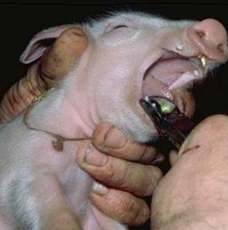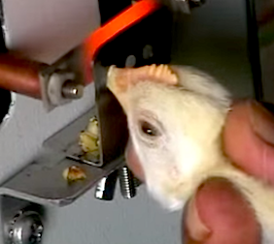
Teeth Clipping (Nearly all piglets Beak Trimming(Most eggs bought
bred for the meat industry will be teeth in shops and supermarkets will have been
clipped). laid by hens that will have been beak trimmed) .
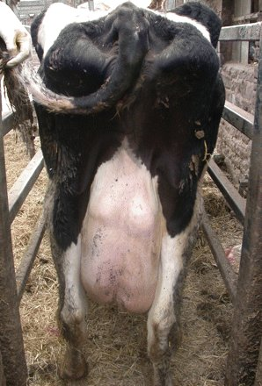
High Milk Yielding Overcrowded living

